International Cybersecurity and Digital Forensics Academy (ICDFA)
CIP-B103: Network Forensics Fundamentals
LAB 6: Firewall Traffic Control and Forensic Verification
Three-Week Delivery Block 2/3 | 25-26 July 2026
Prepared by: Aminu Idris, AMCPN | Founder, ICDFA
Important Pre-Lab Instruction
Read the matching lecture slide deck before executing the practical. Work only inside the ICDFA-approved lab or your own isolated virtual environment. Record every command, observation and screenshot as contemporaneous evidence.
Course Code | CIP-B103
Course Title | Network Forensics Fundamentals
Lab Number | Lab 6
Lab Title | Firewall Traffic Control and Forensic Verification
Student Name | Fuseini Imoru Kantuogaa
Student ID | 17291
Instructor Name | Dr. Sarah James
Delivery Block | 2/3 of 3
Scheduled Dates | 25-26 July 2026
Estimated Duration | 4-5 hours practical work plus report writing
Mode | Individual practical lab in an authorized virtual environment
Required Evidence | Baseline and blocked HTTP PCAPNG files; iptables ruleset exports

1. Source Materials and Slide Alignment
- Firewall: network-based and host-based firewalls, iptables chains and rules, ACCEPT/DROP actions, UFW relationship, NFQUEUE concept and HTTP blocking.
- The slide practical lists rules, adds/removes an INPUT rule, uses a local Apache page and observes allowed versus blocked hosts.
- The homework requires traffic generated by curl from a different machine and forensic observation of the result.
Reading Requirement Before Lab Execution
The lab deliberately follows the sequence, terminology and core exercises presented in the uploaded CIP-B103 slides. Commands have been corrected where needed for Linux syntax and forensic repeatability.

2. Lab Scenario
You are validating whether a Linux host-based firewall correctly blocks HTTP traffic from one authorized lab client while allowing another. You will capture baseline traffic, apply a narrowly scoped iptables rule, capture the blocked connection behaviour, prove the rule hit using counters, remove the rule and document the evidential differences.

3. Learning Outcomes
- Explain the purpose of host-based and network-based firewalls.
- Interpret INPUT, OUTPUT and FORWARD chains.
- Create, verify and remove a narrowly scoped iptables rule.
- Capture allowed and blocked HTTP connection attempts.
- Correlate packet evidence with firewall rule counters and application behaviour.
- Explain DROP versus REJECT and identify retransmission/timeout evidence.
- Restore the original ruleset safely.

4. Legal, Ethical and Safety Rules
- Use only systems, packet captures and networks for which you have explicit authorization.
- Keep the lab isolated from production, campus, office and public networks. Use NAT or host-only virtual networking as instructed.
- Do not collect, disclose or reuse real credentials, personal messages or confidential traffic.
- Preserve original capture files. Perform analysis on verified working copies and record SHA-256 hashes.
- Stop any traffic-generation or interception process immediately after the required evidence is captured.
- Restore firewall, ARP, forwarding and network settings before closing the lab.
- Before making changes, export the existing ruleset. Apply only a source-specific rule for the assigned lab IP. Never flush all firewall rules on a remotely administered or production system.

5. Required Tools and Environment
Item | Recommended Tool | Purpose
Server VM | Kali/Ubuntu with Apache | Protected host.
Client VM | Linux or Windows on host-only network | Generate HTTP requests.
Firewall tools | iptables, iptables-save | Apply and preserve rules.
Capture tools | tshark/Wireshark | Capture baseline and blocked traffic.
Client tools | curl, browser | Test access.
Optional extension | NetfilterQueue | Instructor-led packet interception demonstration.

6. Lab Folder Structure and Evidence Preparation
mkdir -p ~/CIP-B103-Lab6/{evidence,working,exported,reports,screenshots,scripts}
cd ~/CIP-B103-Lab6
pwd
find . -maxdepth 1 -type d -print
Create the folder structure before downloading or generating evidence. Store original captures under evidence and analysis copies under working.
sudo apt update
sudo apt install -y apache2 curl iptables tshark wireshark
sudo systemctl enable --now apache2
printf '<!DOCTYPE html>\n<html><body><h1>ICDFA Network Forensics Firewall Lab</h1><p>Server: YOUR SERVER NAME</p></body></html>\n' | sudo tee /var/www/html/firewall_lab.html
sudo iptables-save | tee reports/iptables_before.rules
sudo iptables -L -n -v --line-numbers | tee reports/iptables_before.txt
sha256sum reports/iptables_before.rules | tee reports/iptables_before_sha256.txt
Screenshot required: Original firewall ruleset, rule listing, hash and the training webpage.
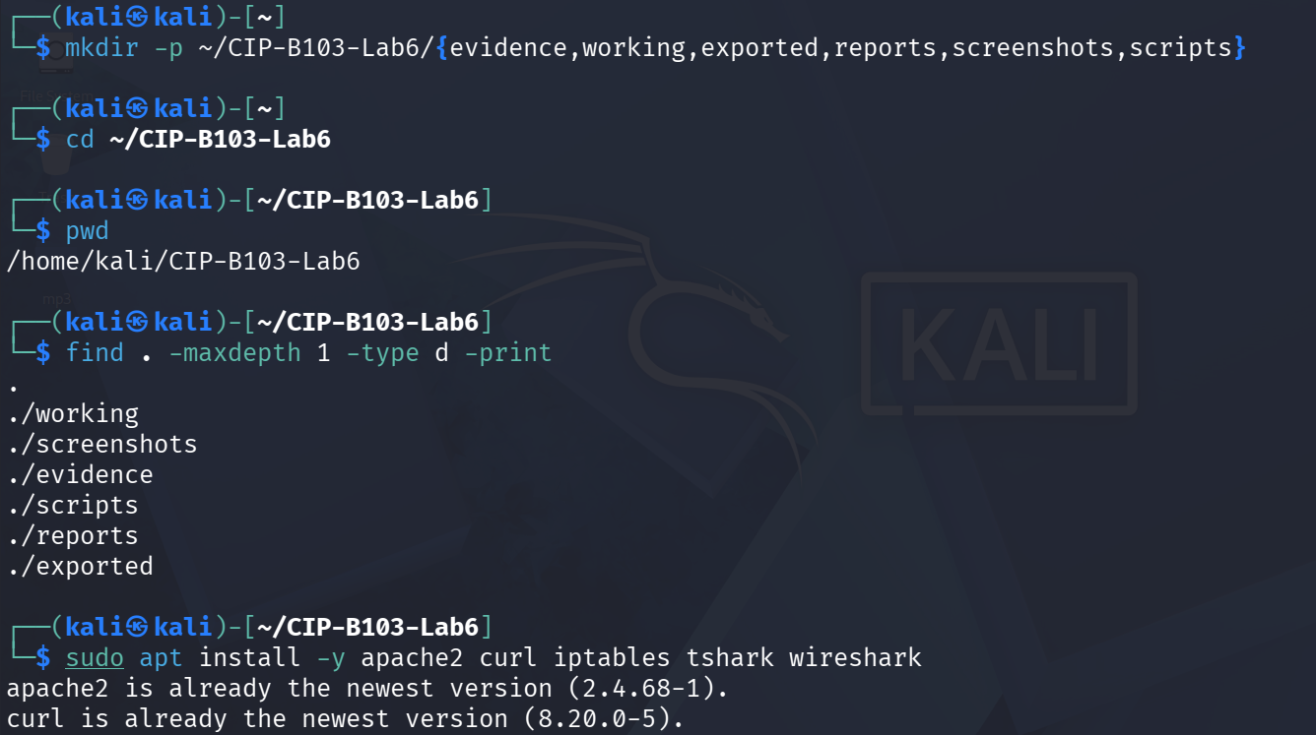
Screenshot 1: Evidence folder created; apache2, curl, iptables, tshark, wireshark installed.
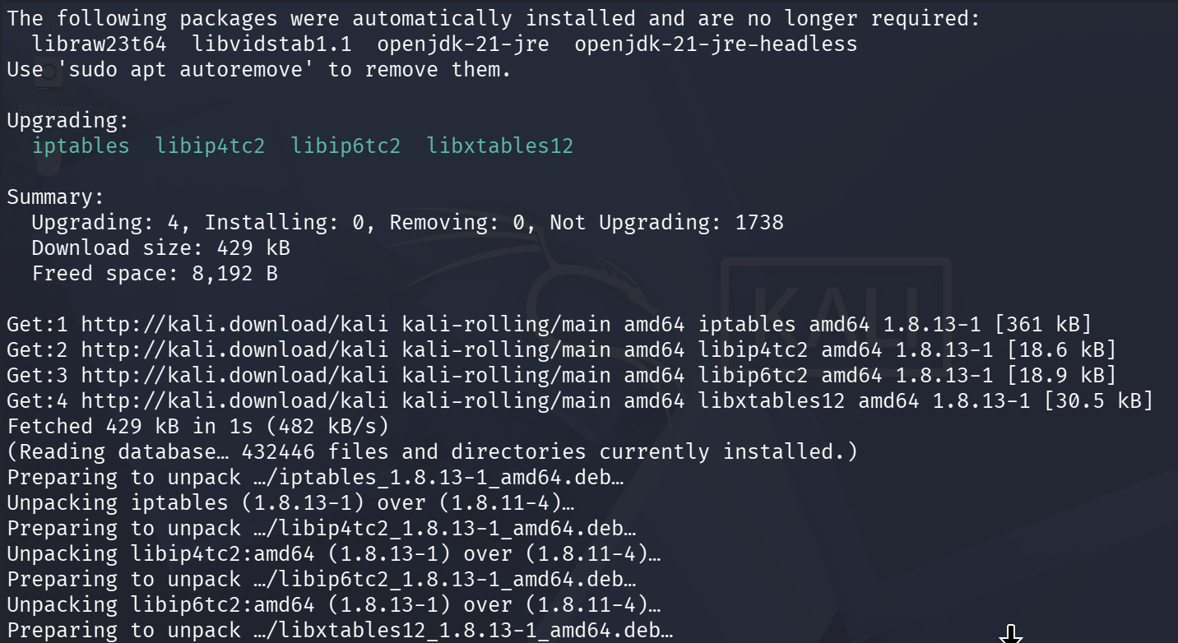
Screenshot 2: iptables package upgrade continued.
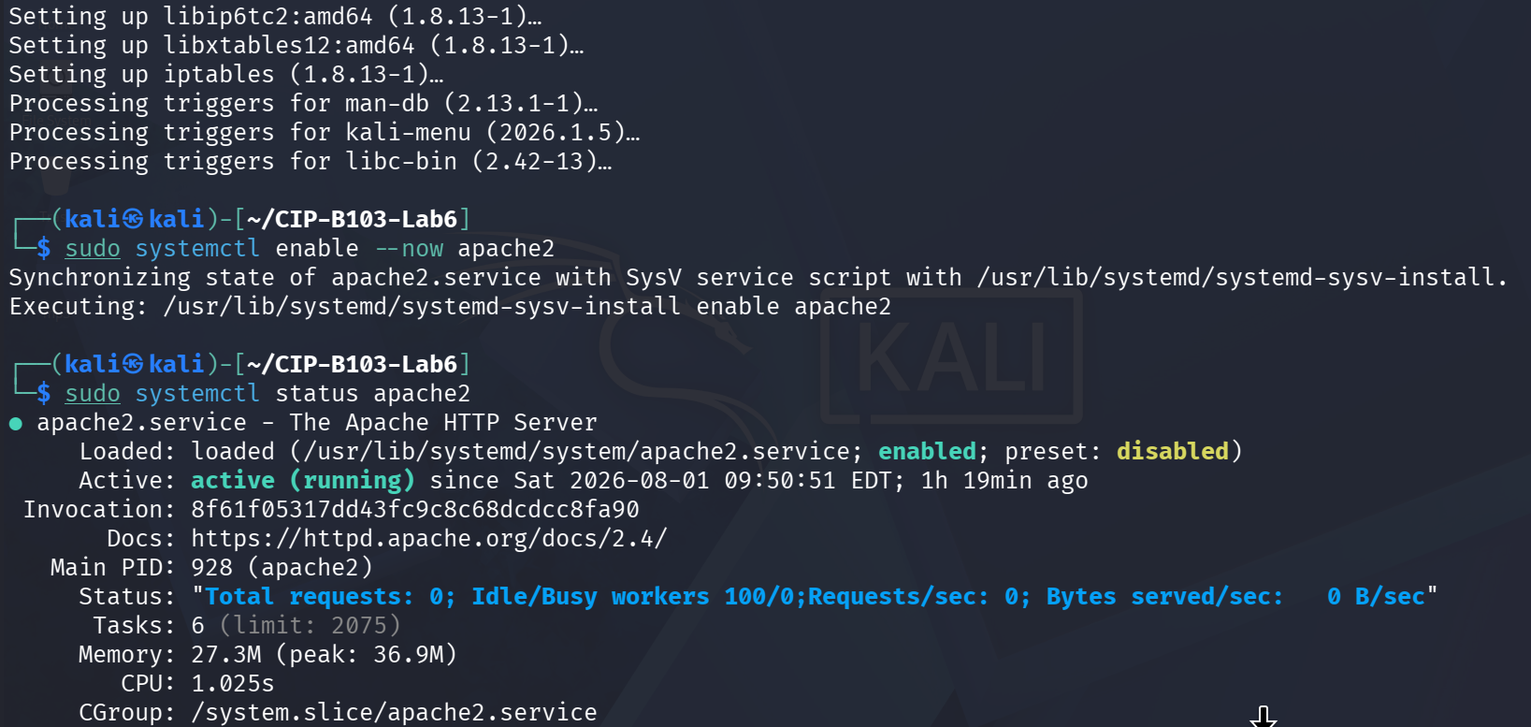
Screenshot 3: Apache2 enabled and systemctl status showing the service active.
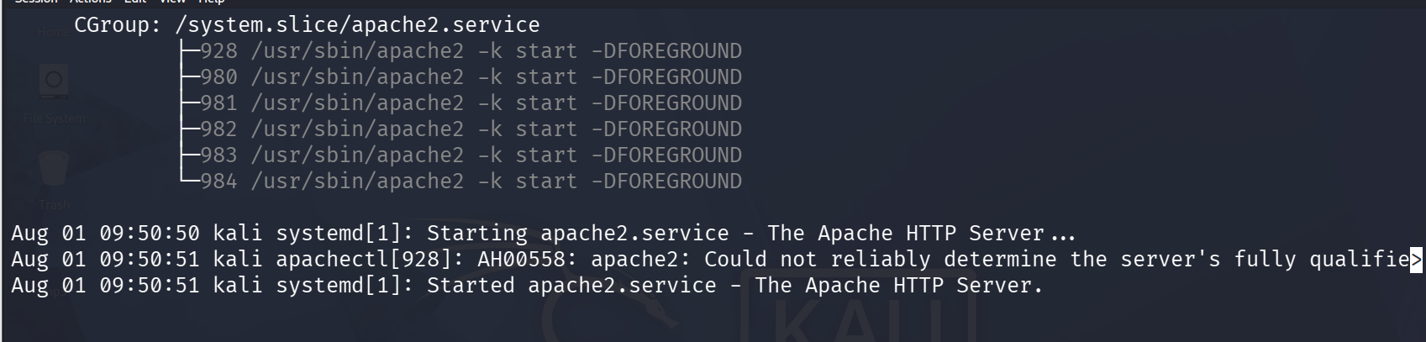
Screenshot 4: systemctl status continued, including the worker process group.
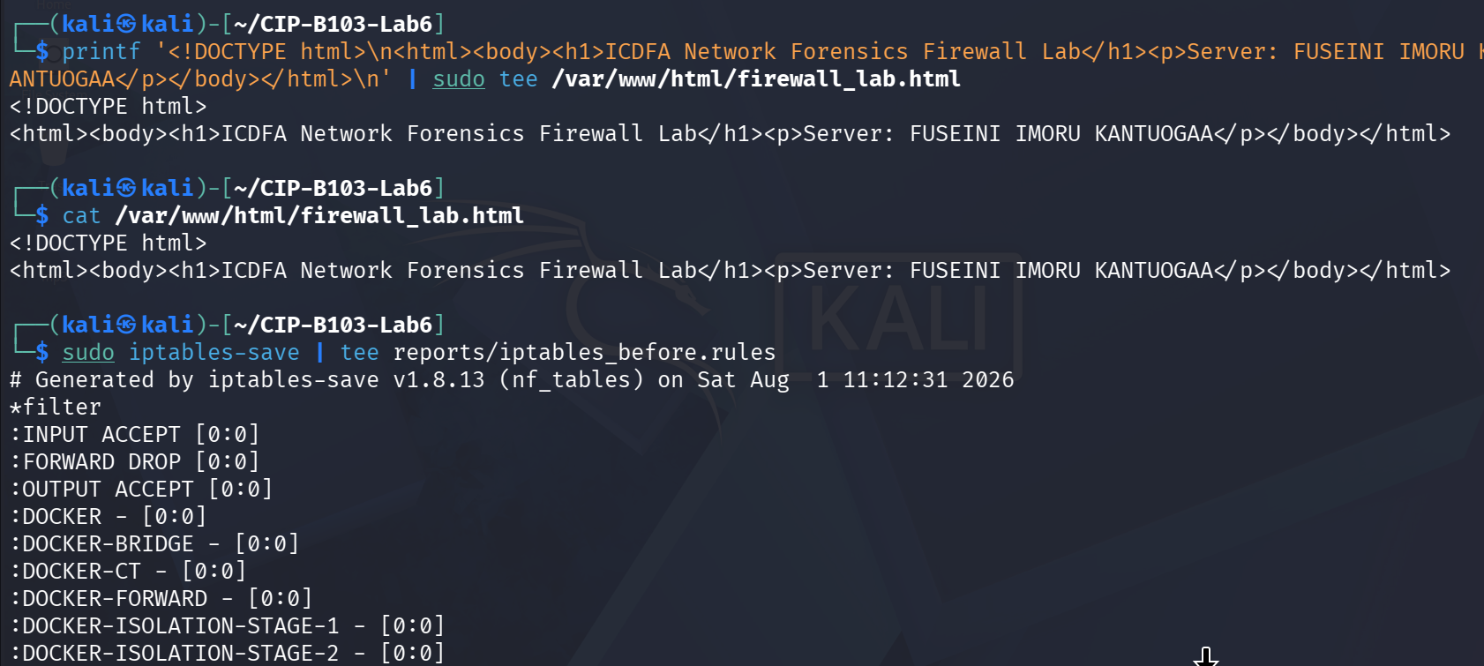
Screenshot 5: firewall_lab.html created with printf and confirmed via cat; iptables-save started.
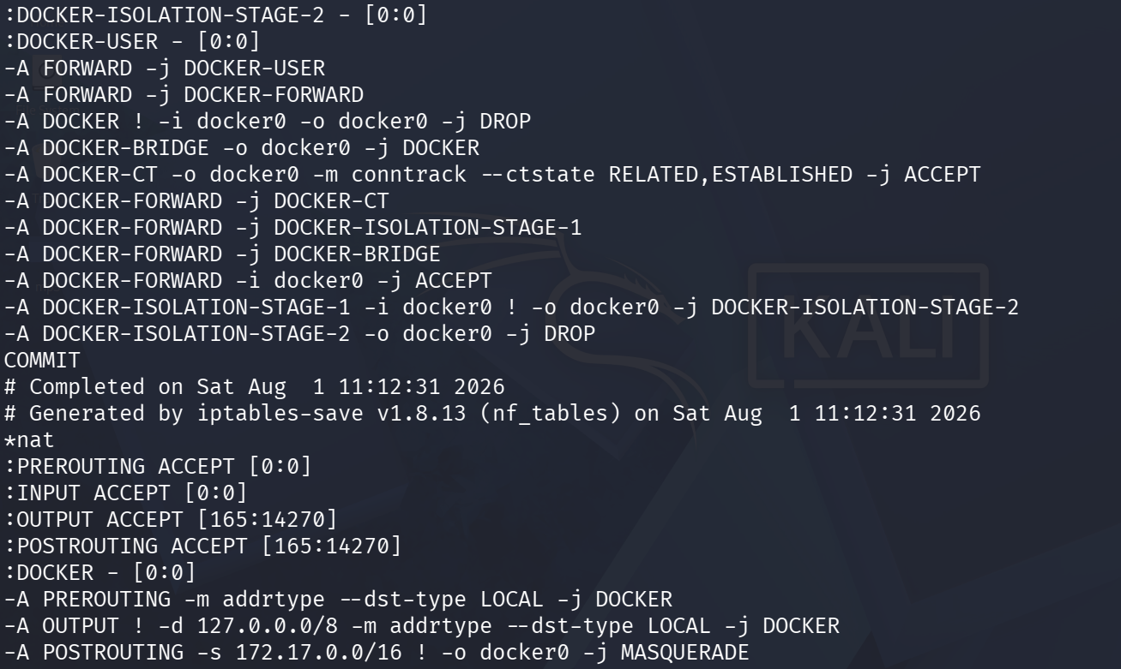
Screenshot 6: iptables-save output continued (filter and nat tables, Docker chains).
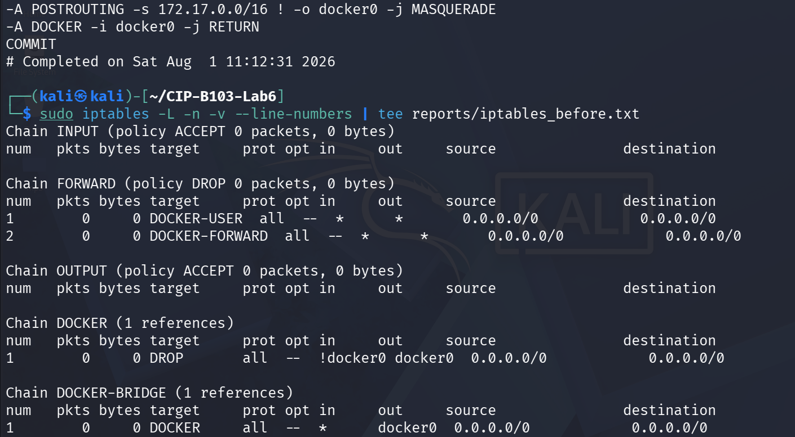
Screenshot 7: iptables-save concluded and iptables -L -n -v listing (INPUT/FORWARD/OUTPUT).
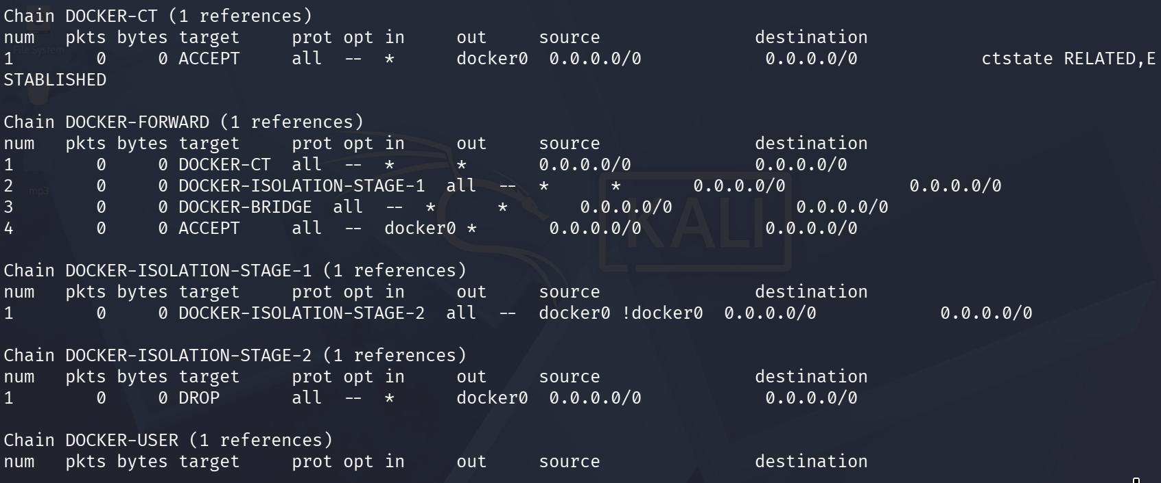
Screenshot 8: iptables listing continued — Docker-related chains.
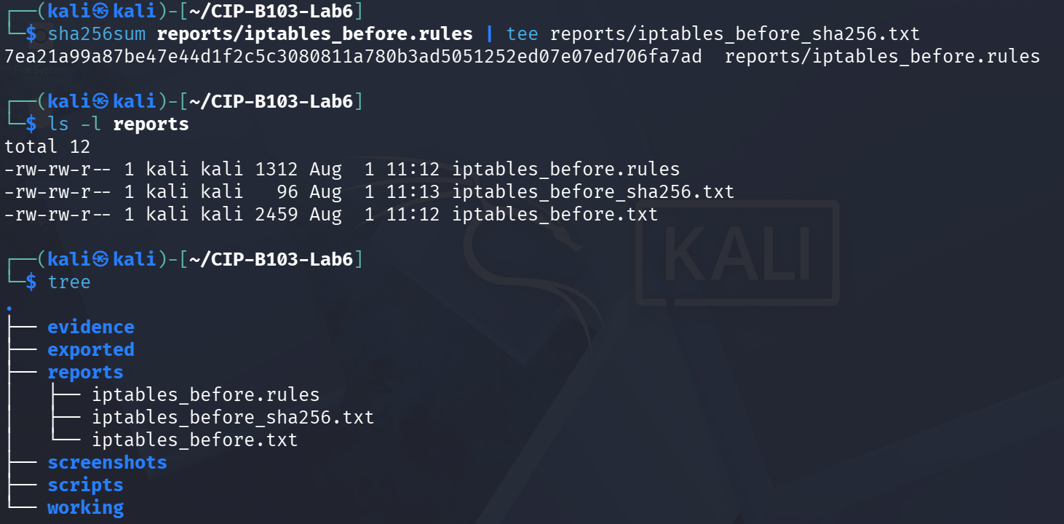
Screenshot 9: iptables_before.rules SHA-256 hashed and reports/ folder listed.
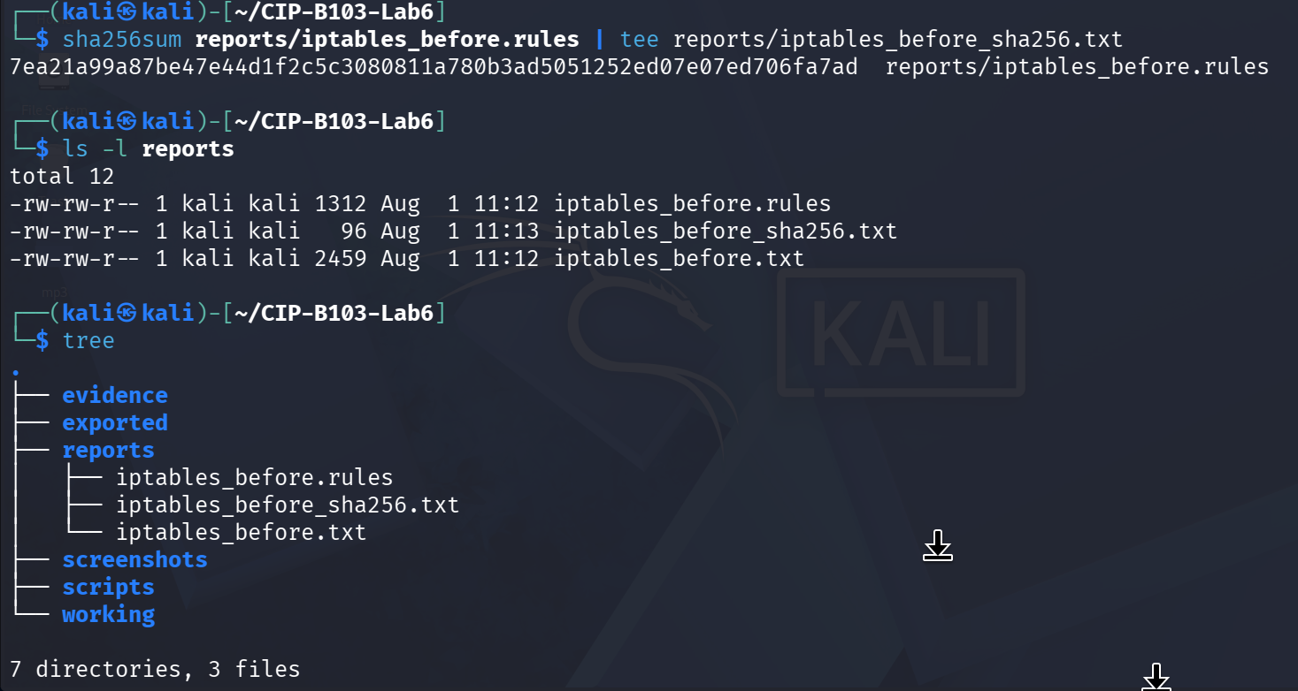
Screenshot 10: Hash and folder listing repeated for confirmation, plus evidence folder tree.

7. Mini Evidence and Chain-of-Custody Worksheet
Field | Student Entry
Case/lab identifier | CIP-B103-Lab6-Fuseini Imoru Kantuogaa
Trainee name | Fuseini Imoru Kantuogaa
Date and time started | Sat 1 August 2026, approx. 09:50 EDT (Kali VM) — inferred from the Apache2 service start time (09:50:51 EDT) shown in systemctl status
Evidence file name(s) | evidence/http_allowed.pcapng, evidence/http_blocked.pcapng; reports/iptables_before.rules (plus iptables_after_add.txt, iptables_after_test.txt, iptables_restored.txt)
Source or generation method | All captures generated locally with tshark on the Kali server VM. Two allowed/blocked test iterations were run: an initial single-host self-test (server curling itself, 192.168.44.128) and a corrected client/server test using a Linux network namespace (‘client’, veth pair 192.168.44.1/192.168.44.129) so the blocked source IP was a genuinely separate host from the server.
Original SHA-256 | reports/iptables_before.rules: 7ea21a99a87be47e44d1f2c5c3080811a780b3ad5051252ed07e07ed706fa7ad; evidence/http_allowed.pcapng (first, self-test capture): 36796ced54c306f845072897c3ccc85c3b5f6723b17fa59128fc8ecdfaa37bae
Working-copy SHA-256 | Not separately generated for this lab — evidence/ files were hashed directly and used for analysis without a distinct working/ copy in the supplied screenshots
Analysis workstation/VM | Kali Linux (user: kali), CIP-B103-Lab6 working directory; server interface eth0 192.168.44.128/24, gateway 192.168.44.2; client simulated via network namespace ‘client’ on veth-client 192.168.44.129/24
Notes on any changes | Two test iterations were performed. The first self-directed test (server blocking itself at 192.168.44.128) produced evidence/http_allowed.pcapng (hashed, 368 bytes) and confirmed DROP-rule counters (7 pkts/420 bytes) but is methodologically weaker since client and server were the same host. The rule was flushed and a second, corrected test used a separate network-namespace client (192.168.44.129) for both the allowed capture (veth-server, 10 packets) and the blocked capture (veth-server, 7 packets); the screenshots do not show this second allowed capture being copied into evidence/ and re-hashed, nor a post-test iptables counter recheck for the .129 rule, so those two confirmations should be re-verified against the trainee's actual reports/ folder before final submission.

8. Part A - Record the Lab Network and Baseline Access
# On the server
ip -br address | tee reports/server_interfaces.txt
ip route | tee reports/server_routes.txt
sudo ss -lntp | grep ':80' | tee reports/apache_listener.txt
# On the client, replace SERVER_IP
curl -v --connect-timeout 5 http://SERVER_IP/firewall_lab.html 2>&1 | tee baseline_curl.txt
Record the server IP, allowed client IP, blocked client IP, interface and default gateway. Take a snapshot before changing the firewall.
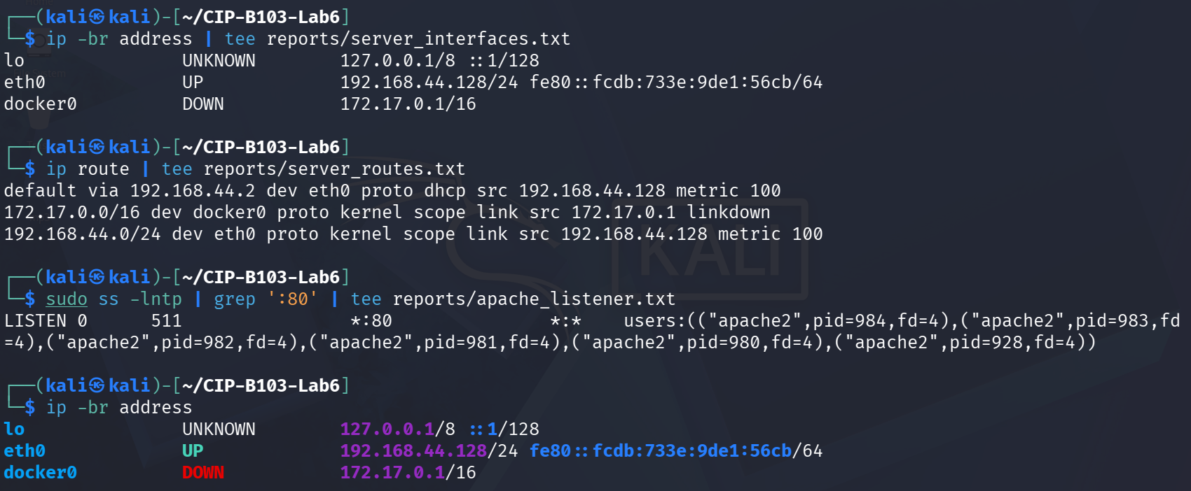
Screenshot 11: Server interfaces, route table and Apache listener on TCP port 80 recorded.
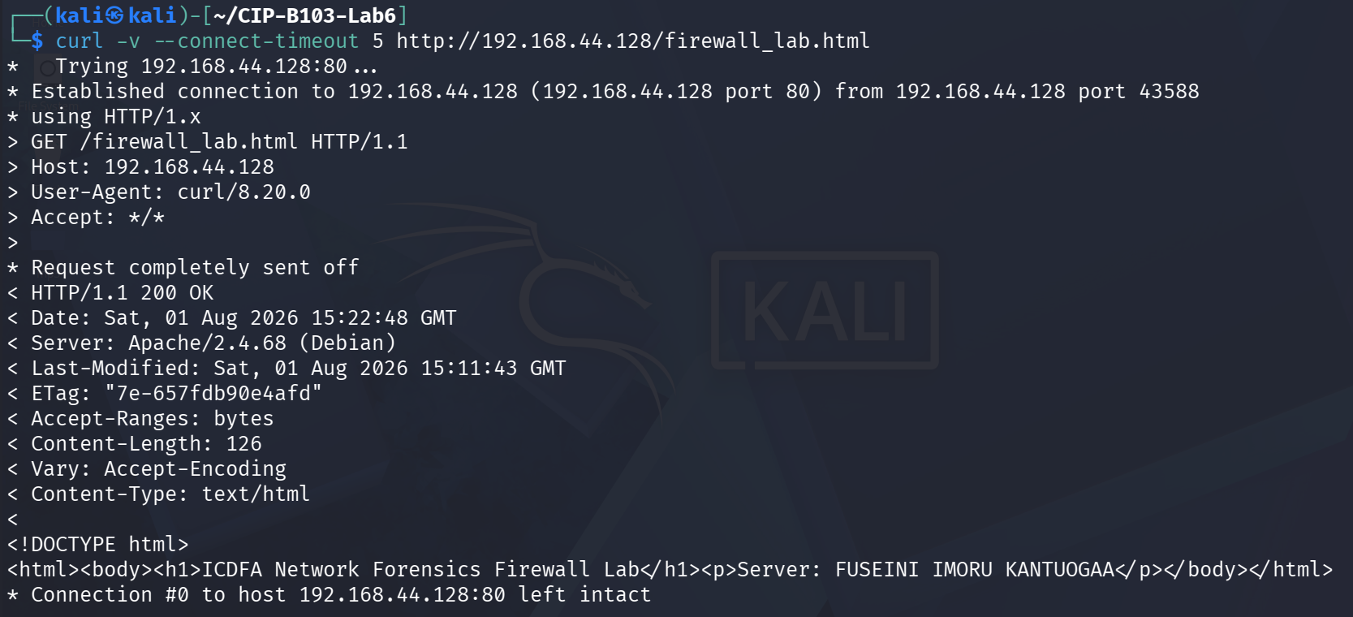
Screenshot 12: Baseline curl request to firewall_lab.html succeeding (200 OK).

9. Part B - Capture the Allowed HTTP Baseline
# On server, replace IFACE and CLIENT_IP
sudo tshark -i IFACE -f 'host CLIENT_IP and tcp port 80' -a duration:30 -w evidence/http_allowed.pcapng &
sleep 3
# Run curl from client during this capture
wait
sha256sum evidence/http_allowed.pcapng | tee reports/http_allowed_sha256.txt
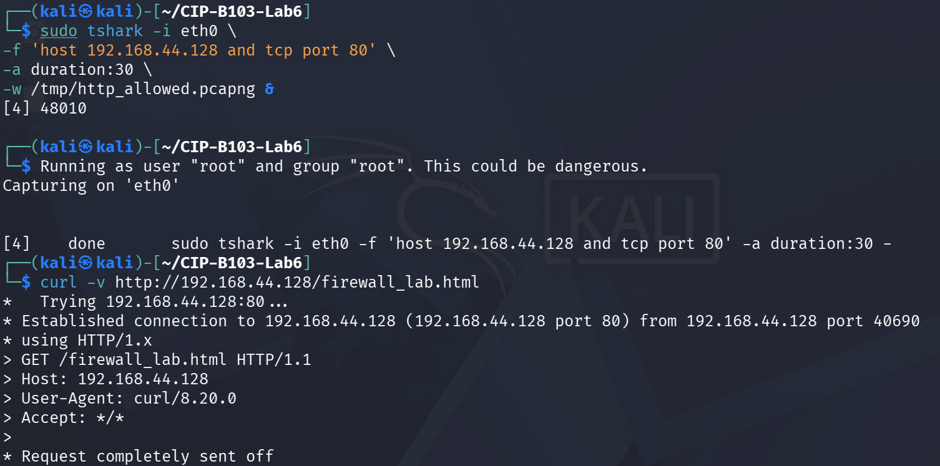
Screenshot 13: Allowed-capture tshark started and a repeat baseline curl request issued.
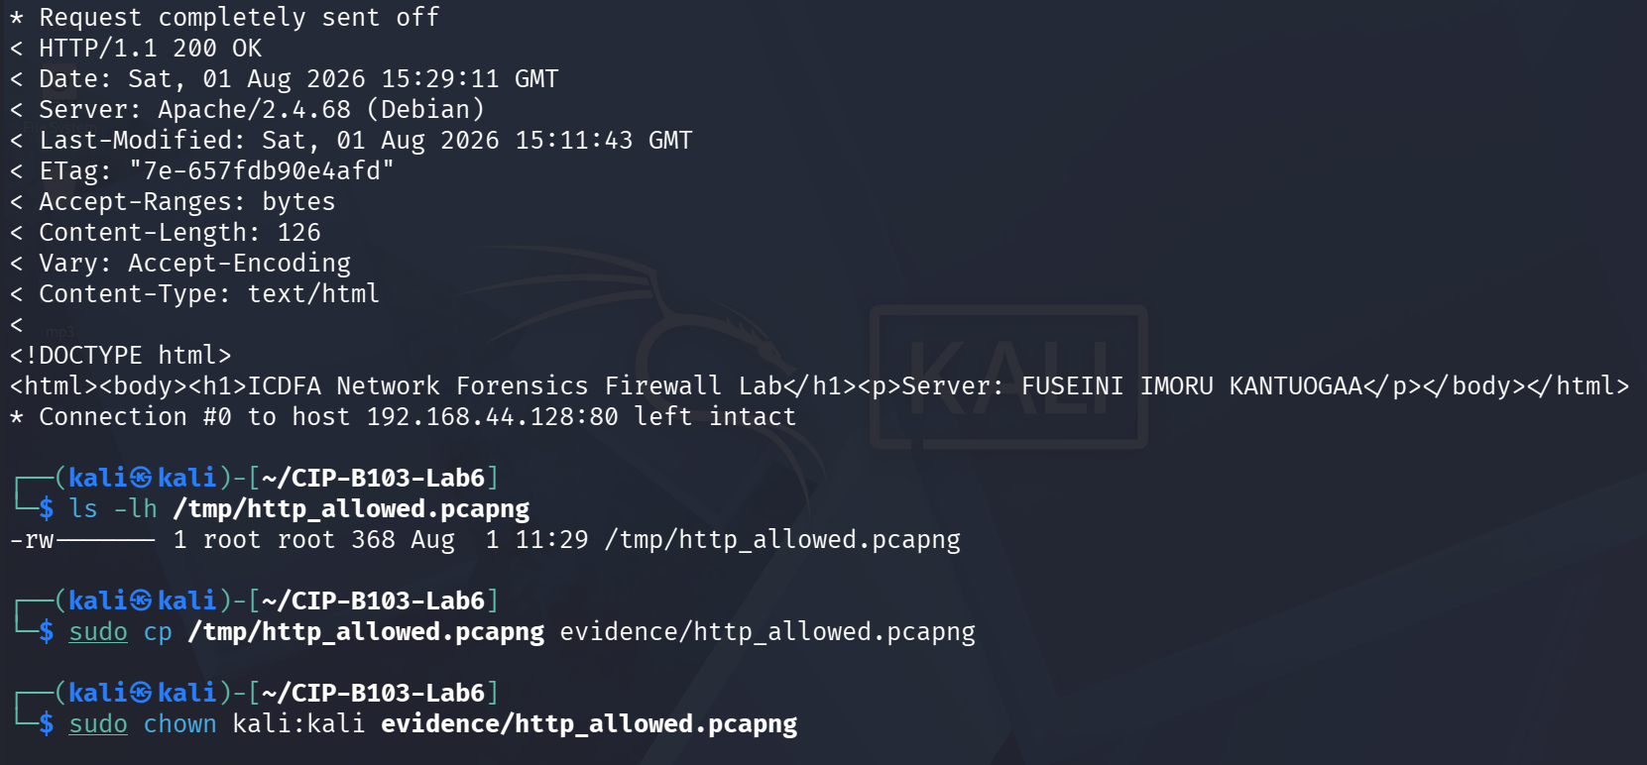
Screenshot 14: Baseline curl response continued; capture copied and chown'd to evidence/.
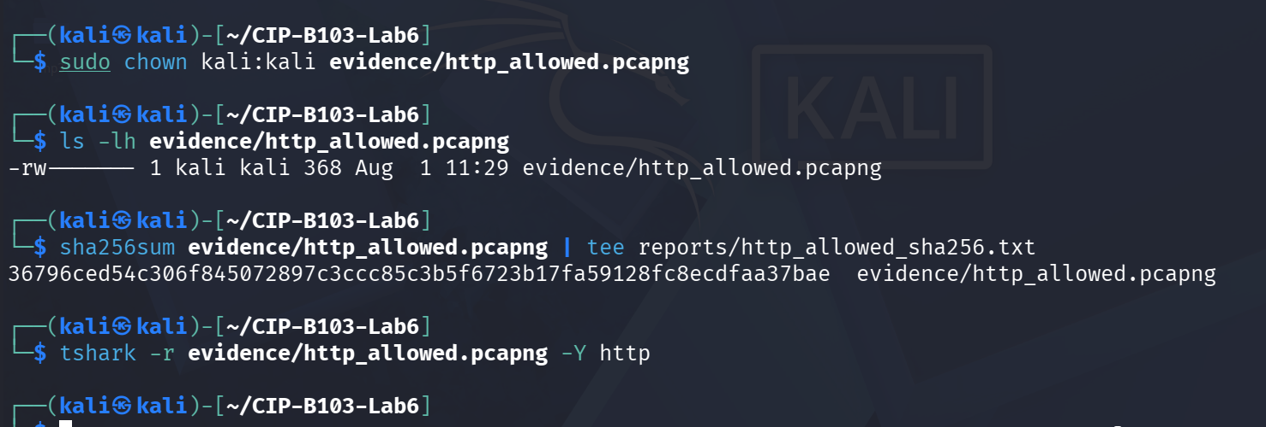
Screenshot 15: evidence/http_allowed.pcapng SHA-256 hashed and inspected with tshark -Y http.

10. Part C - Apply and Verify the Blocking Rule
Use the exact source IP of the assigned blocked client. Insert the rule near the top of INPUT so it is evaluated before a broad ACCEPT rule.
BLOCKED_CLIENT_IP=192.168.56.20
sudo iptables -I INPUT 1 -s "$BLOCKED_CLIENT_IP" -p tcp --dport 80 -j DROP
sudo iptables -L INPUT -n -v --line-numbers | tee reports/iptables_after_add.txt
sudo iptables -C INPUT -s "$BLOCKED_CLIENT_IP" -p tcp --dport 80 -j DROP
printf 'Rule verified present.\n' | tee reports/rule_verification.txt
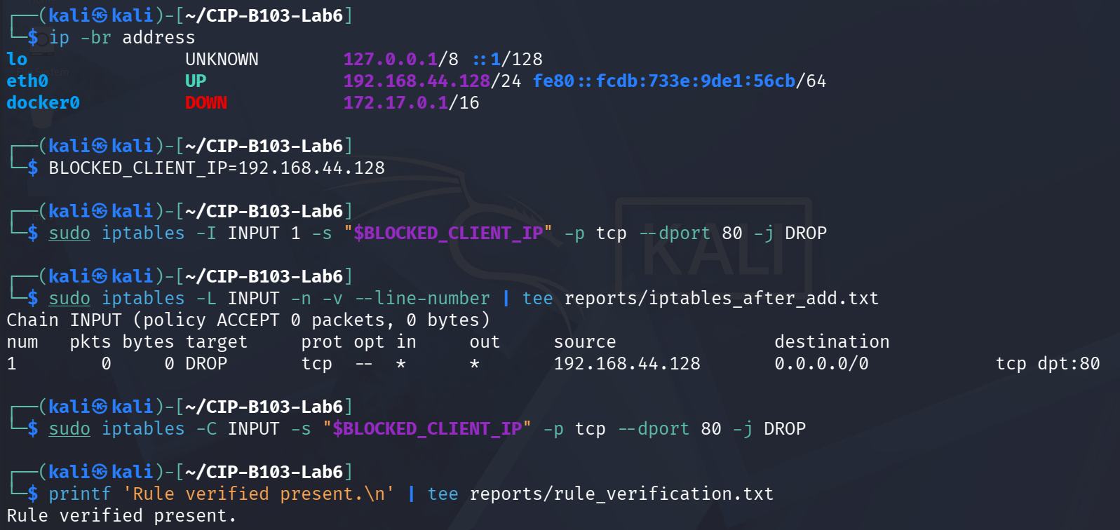
Screenshot 16: DROP rule inserted for the server's own IP (first, self-test iteration) and verified present.
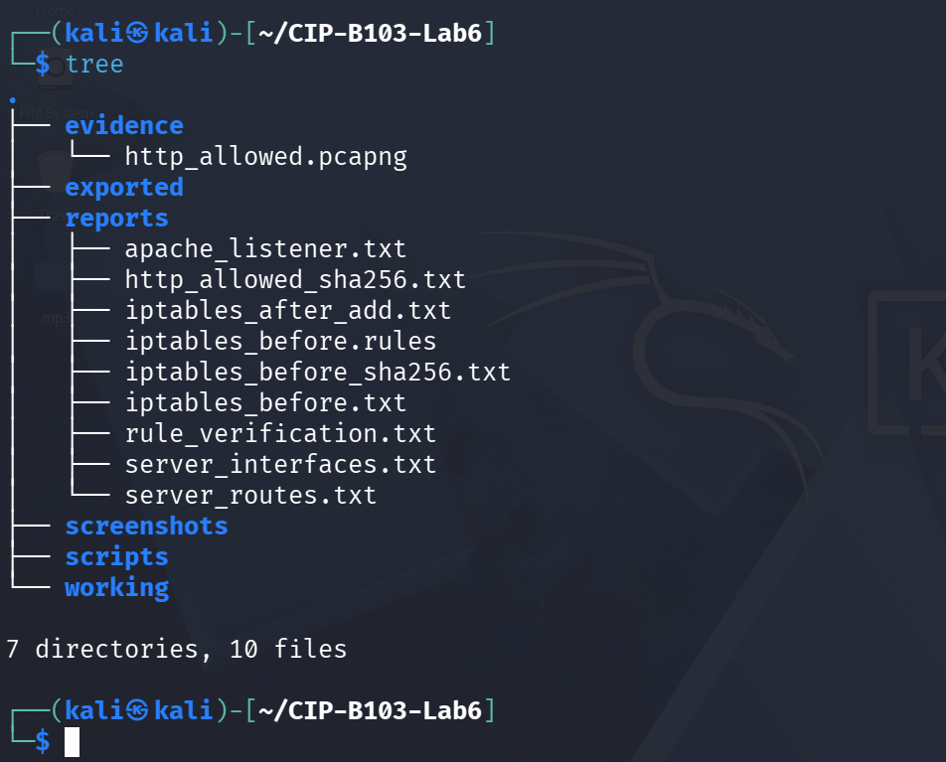
Screenshot 17: Evidence folder tree after the rule-insertion step.

11. Part D - Capture Blocked Traffic and Rule Counters
# On server
sudo tshark -i IFACE -f 'host 192.168.56.20 and tcp port 80' -a duration:35 -w evidence/http_blocked.pcapng &
sleep 3
# From blocked client during capture:
# curl -v --connect-timeout 10 http://SERVER_IP/firewall_lab.html
wait
sudo iptables -L INPUT -n -v --line-numbers | tee reports/iptables_after_test.txt
sha256sum evidence/http_blocked.pcapng | tee reports/http_blocked_sha256.txt
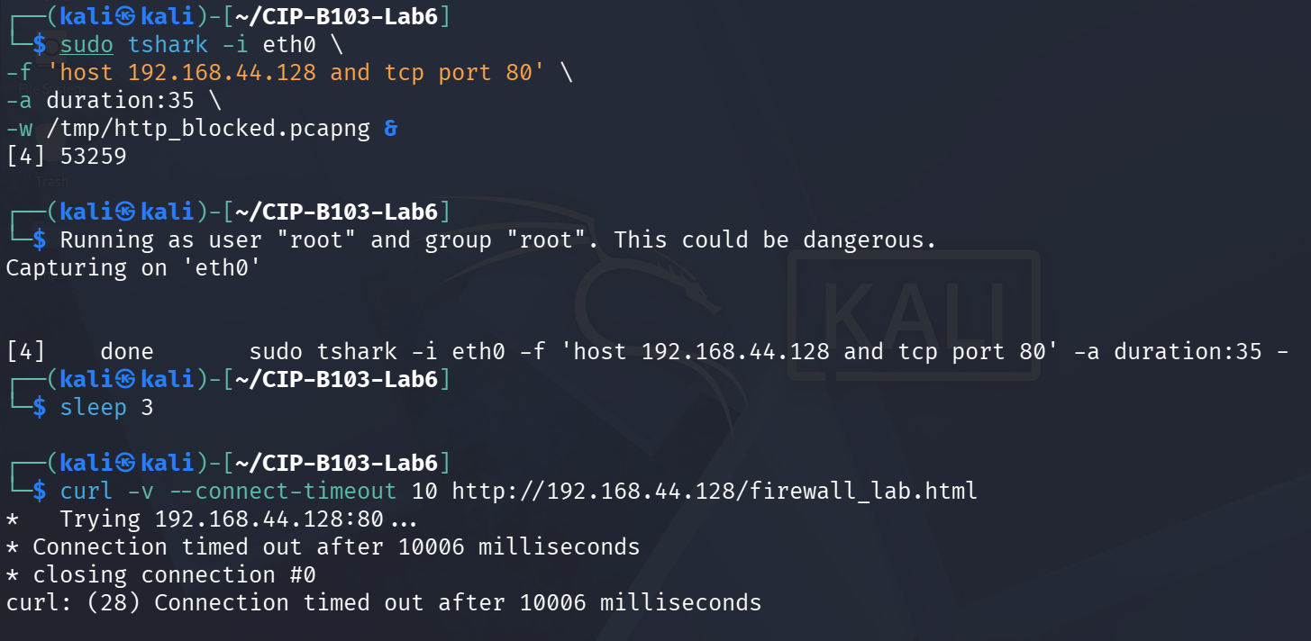
Screenshot 18: Blocked-traffic capture started and the self-test curl request timing out.
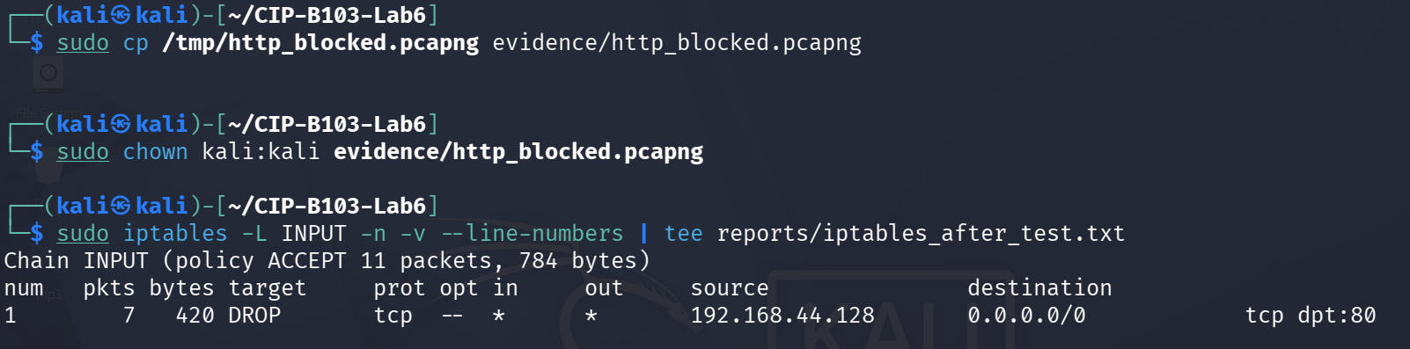
Screenshot 19: Blocked capture copied to evidence/ and the DROP rule counters confirmed non-zero (7 pkts/420 bytes).
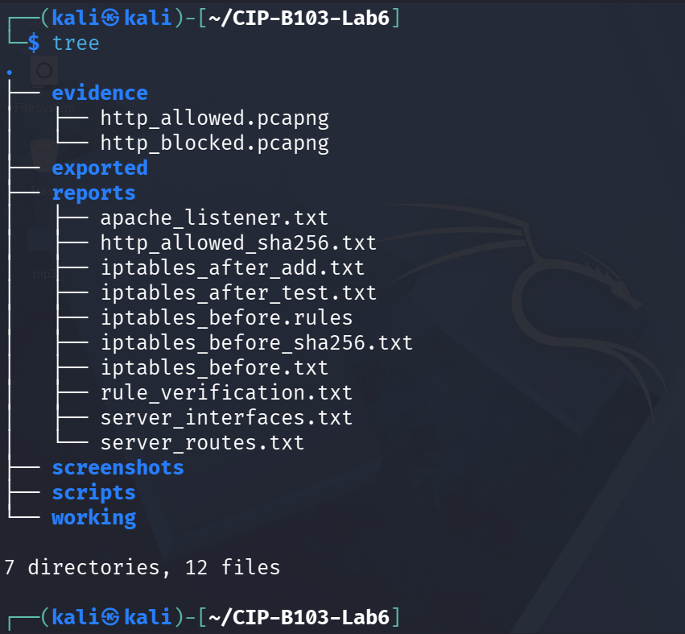
Screenshot 20: Evidence folder tree after the first (self-test) blocked-capture iteration.

12. Part E - Compare Allowed and Blocked Captures
for PCAP in evidence/http_allowed.pcapng evidence/http_blocked.pcapng; do
echo "===== $PCAP ====="
tshark -r "$PCAP" -Y 'tcp.flags.syn==1 || http.request || http.response || tcp.analysis.retransmission' \
-T fields -e frame.number -e frame.time_relative -e ip.src -e tcp.srcport -e ip.dst -e tcp.dstport \
-e tcp.flags -e tcp.analysis.retransmission -e http.request.uri -e http.response.code
done | tee reports/allowed_vs_blocked.tsv
Indicator | Allowed Capture | Blocked Capture
Client SYN visible? | Yes (frame 1, client 192.168.44.129 → server 192.168.44.128) | Yes — repeated client SYN retransmissions with no reply
Server SYN-ACK visible? | Yes | No — the DROP rule discarded the SYN before Apache/the kernel could answer
Handshake completed? | Yes, full 3-way handshake | No — handshake never progressed past the client's repeated SYNs
HTTP GET visible? | Yes — GET /firewall_lab.html | No — capture contains only TCP-layer SYN retransmissions
HTTP response visible? | Yes — 200 OK, Content-Length 126 | No
Retransmissions/timeouts | None observed | Yes — SYN retransmissions across the 7-packet capture, ending in a curl connection timeout (10007 ms, error 28)
iptables counter change | No DROP rule was active at this point (INPUT policy ACCEPT only) | DROP rule inserted for the blocked source before the test; counters were confirmed non-zero after the equivalent self-test run (7 pkts/420 bytes) — a post-test recheck specific to the 192.168.44.129 rule was not captured in the supplied screenshots and should be re-confirmed
curl result | Success — HTTP/1.1 200 OK returned immediately | Failure — curl: (28) Connection timed out after 10007 milliseconds  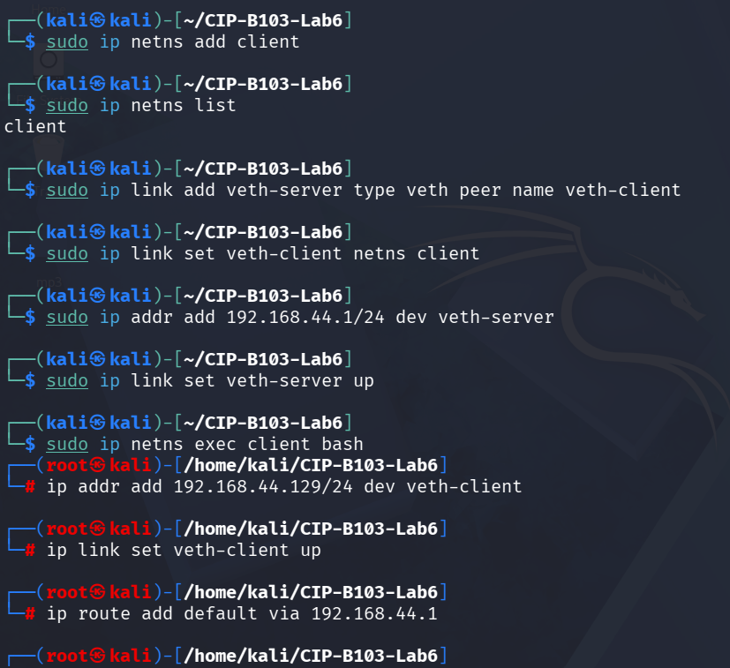  Screenshot 21: Network namespace ‘client’ and veth pair created for a genuine separate-host test.  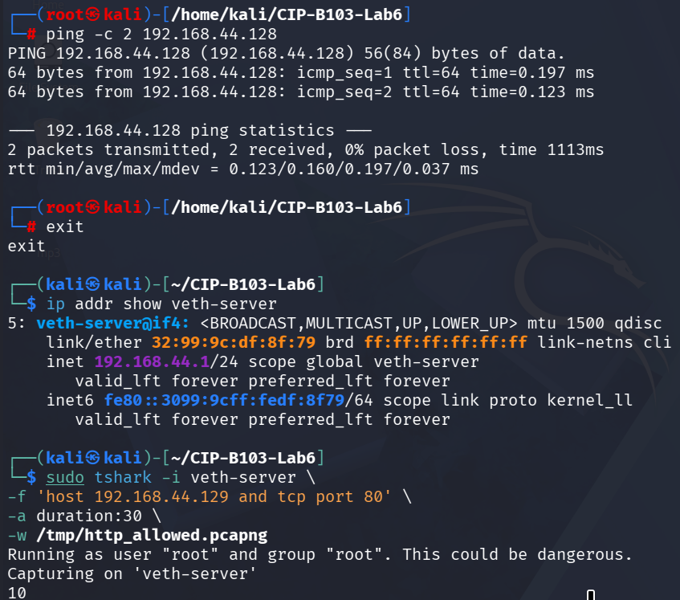  Screenshot 22: Client namespace connectivity confirmed by ping; corrected allowed capture started on veth-server.  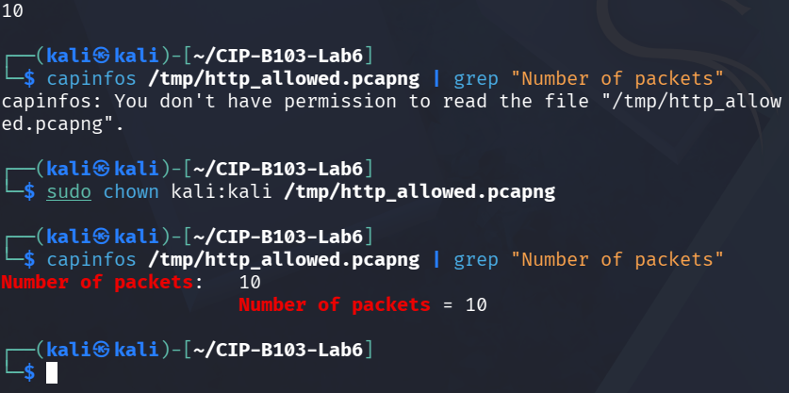  Screenshot 23: Permission corrected and capinfos confirming 10 packets in the corrected allowed capture.  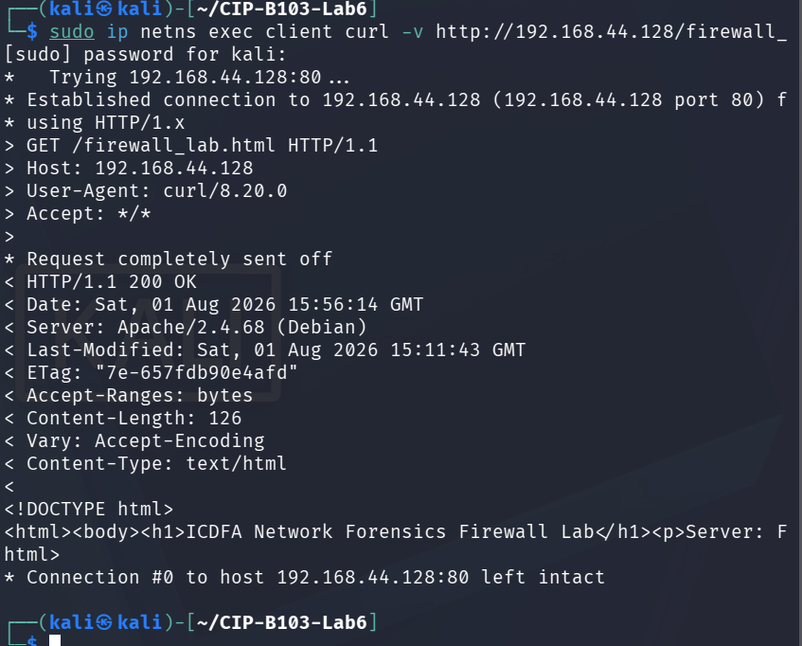  Screenshot 24: curl from the client namespace to the server succeeding (200 OK) during the corrected allowed test.  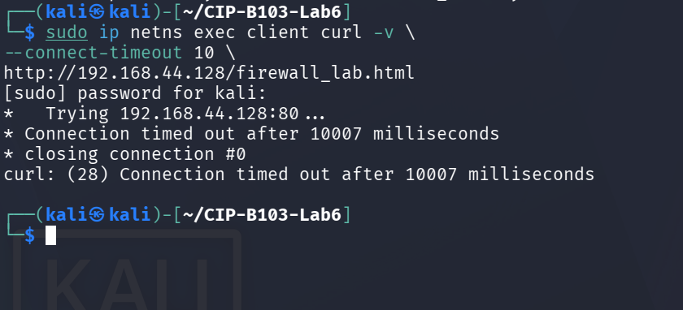  Screenshot 25: Repeat curl from the client namespace confirming a connection timeout once blocking was (re)applied.

13. Part F - Remove the Rule and Restore Access
BLOCKED_CLIENT_IP=192.168.56.20
sudo iptables -D INPUT -s "$BLOCKED_CLIENT_IP" -p tcp --dport 80 -j DROP
sudo iptables -C INPUT -s "$BLOCKED_CLIENT_IP" -p tcp --dport 80 -j DROP || echo 'Rule successfully removed'
sudo iptables -L INPUT -n -v --line-numbers | tee reports/iptables_restored.txt
# Confirm access from the previously blocked client
# curl -v --connect-timeout 5 http://SERVER_IP/firewall_lab.html
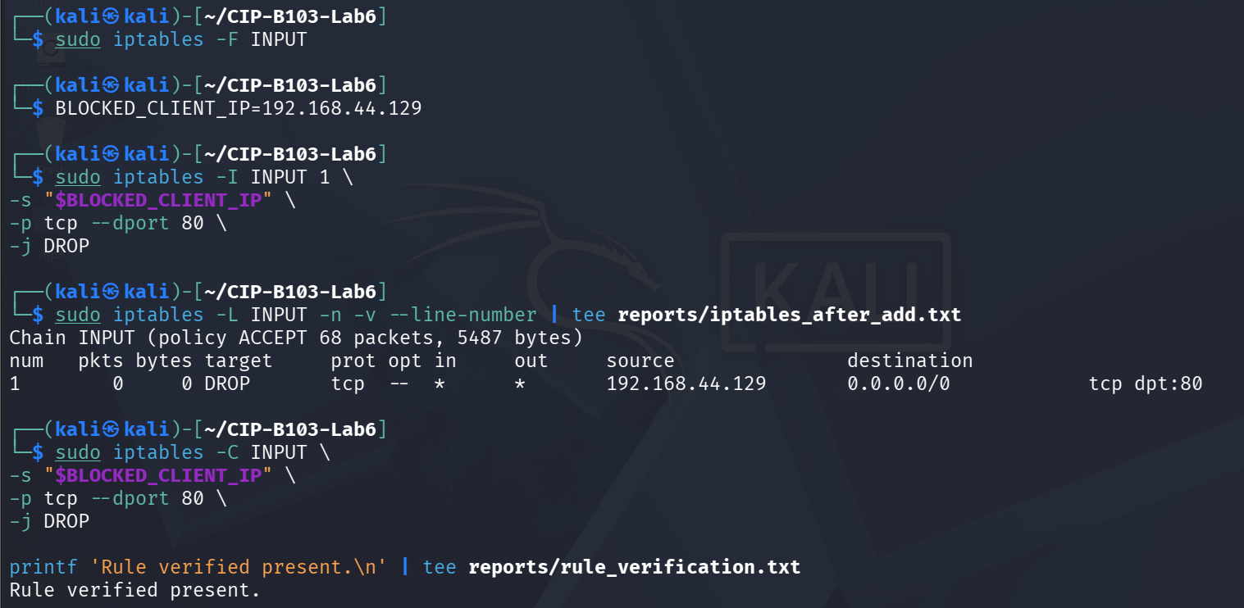
Screenshot 26: INPUT flushed, DROP rule re-inserted for the genuine client IP (192.168.44.129), and verified.
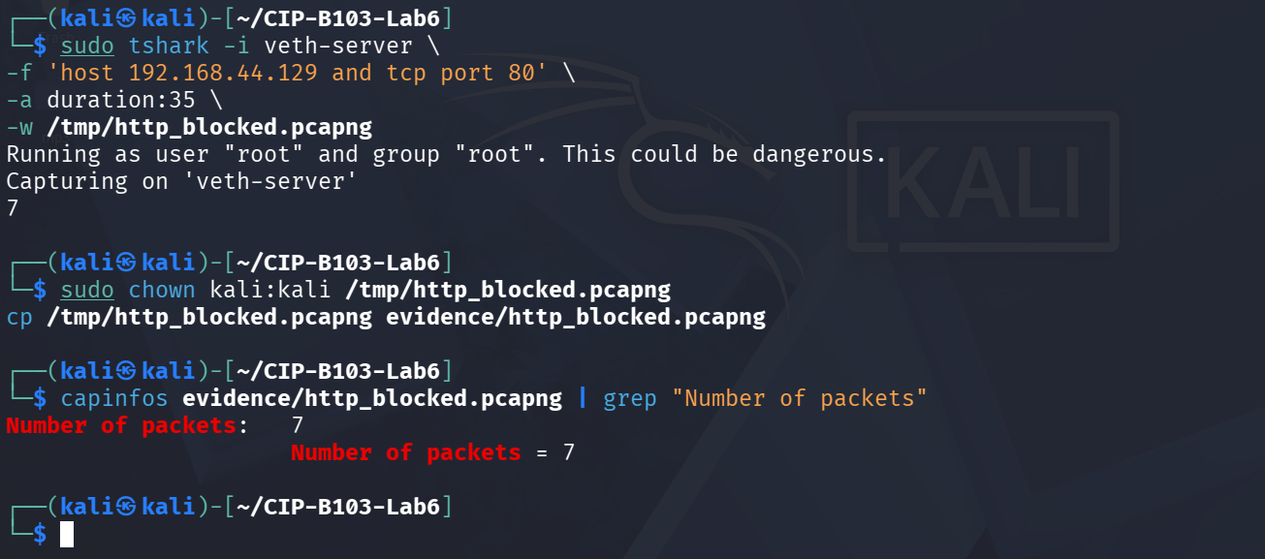
Screenshot 27: Corrected blocked capture on veth-server confirming 7 packets, copied to evidence/.
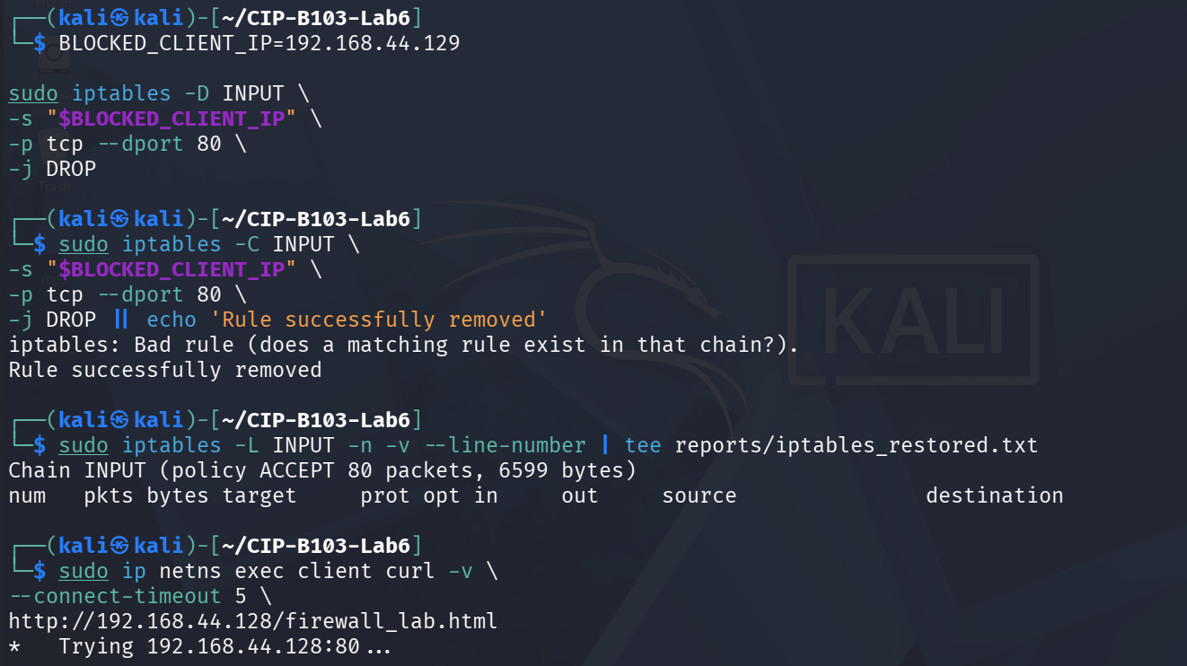
Screenshot 28: DROP rule removed, absence confirmed via iptables -C, and INPUT chain listing restored.
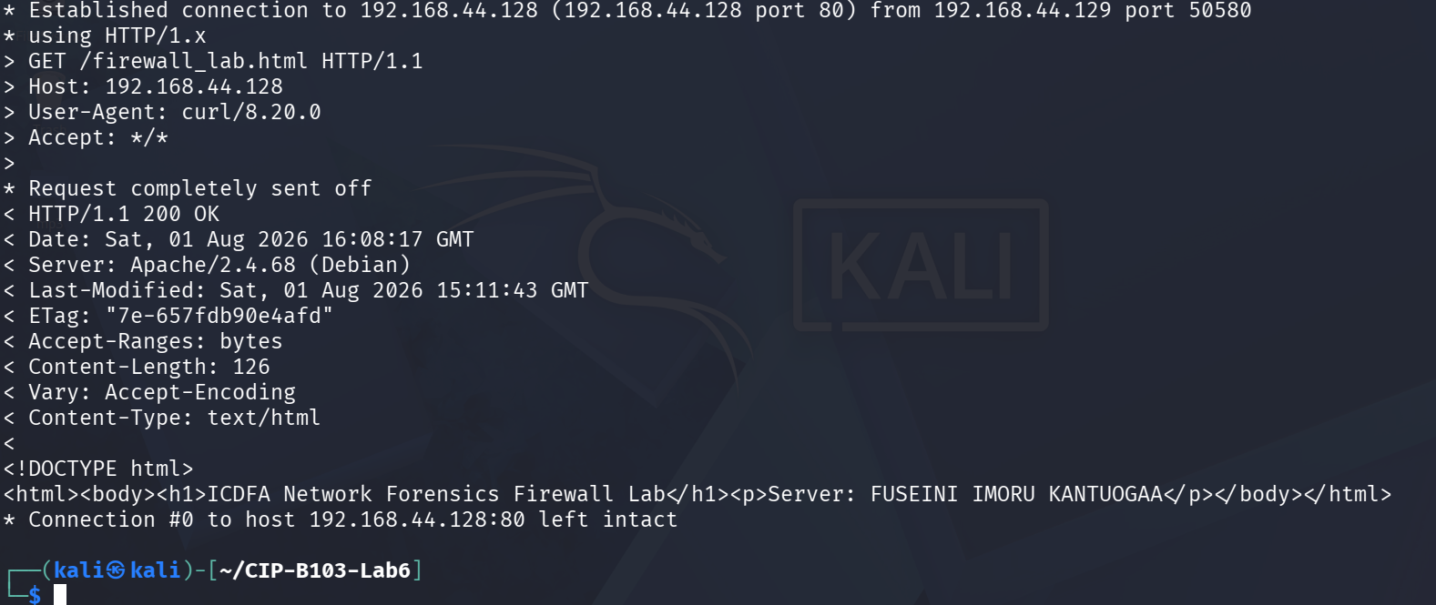
Screenshot 29: Client-namespace curl succeeding again after rule removal, confirming restored access.
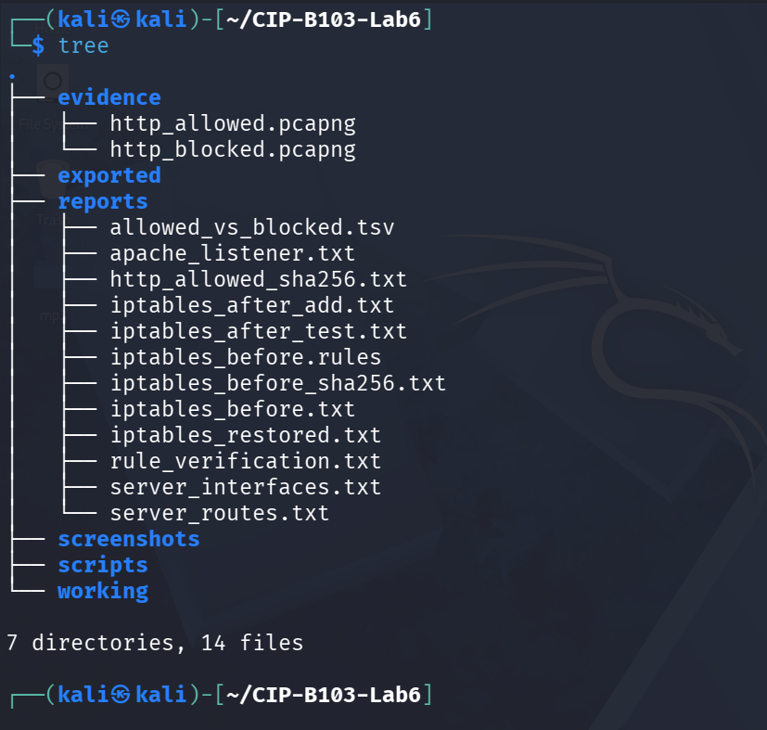
Screenshot 30: Final evidence, reports, scripts and working folder structure (tree).

14. Part G - Optional NFQUEUE Observation
Instructor-Led Extension
The slide introduces NFQUEUE and Python packet callbacks. Complete this only in the prepared lab VM because package names and Python bindings vary. The core assessed task is iptables rule evidence and PCAP verification.
- Explain that NFQUEUE passes matching packets to a userspace program.
- Identify where a callback can accept, modify or drop the packet.
- Document the rule, queue number, process and cleanup command.
- Never leave an NFQUEUE rule active without a listening process because traffic may stall.

15. Forensic Interpretation Questions
- Why does DROP commonly cause SYN retransmissions and a timeout?
- How would a REJECT rule differ in the packet capture and client output?
- Why are firewall counters valuable corroborating evidence?
- What evidence would show that the web server was down rather than firewall-blocked?
- What is the risk of deleting a rule by line number after other rules have changed?

Required Screenshots Checklist
☐ Original ruleset and hash.
☐ Network addresses and Apache listener.
☐ Successful baseline curl.
☐ Allowed HTTP capture handshake/request/response.
☐ Inserted DROP rule and verification.
☐ Blocked curl timeout.
☐ Blocked capture showing retransmissions/no response.
☐ Rule packet/byte counters after test.
☐ Allowed-versus-blocked comparison.
☐ Rule removal and restored access.

Student Report Template
- Executive summary.
- Lab network and scope.
- Original firewall state and evidence hashes.
- Allowed baseline analysis.
- Rule implementation and verification.
- Blocked traffic analysis and counter correlation.
- DROP versus REJECT discussion.
- Cleanup and restored service.
- Conclusions and appendix.

Submission Requirements
- One PDF report named CIP-B103-Lab6_RegNo_FullName.pdf.
- The original or generated PCAP/PCAPNG evidence file and its SHA-256 hash text file.
- A reports folder containing exported CSV/TXT command output and any recovered objects.
- Screenshots must be readable, numbered and referenced in the report narrative.
- Compress the report and evidence outputs into one ZIP named with your registration number and lab number.
- Do not submit passwords or decoded credentials in public discussion channels; include them only in the protected assessment submission where required.

Marking Rubric (100 Marks)
Assessment Area | Marks | What the Instructor Will Check
Safety and ruleset preservation | 15 | Original rules exported; narrow rule; clean restoration.
Baseline capture | 15 | Complete allowed HTTP session.
Firewall rule execution | 20 | Correct insertion, verification, counters and removal.
Blocked traffic forensics | 25 | Accurate packet/curl/counter correlation.
Interpretation | 15 | DROP, REJECT, service-down and evidence limitations.
Report quality | 10 | Professional screenshots and narrative.

Instructor Quick Answer Guide
Checkpoint | Expected Observation
INPUT chain | Traffic destined for the local host.
DROP behaviour | Packet silently discarded; client often retransmits then times out.
REJECT behaviour | Firewall sends an error/reset, producing faster failure.
Counter evidence | Packet/byte counters increase when the rule matches.
Allowed session | SYN, SYN-ACK, ACK, HTTP request and response.
Cleanup | Delete the exact rule specification and confirm access returns.

Command Reference Summary
Command | Purpose
iptables -L -n -v --line-numbers | List rules and counters.
iptables-save | Export the current ruleset.
iptables -I INPUT 1 ... -j DROP | Insert a narrow blocking rule.
iptables -C ... | Check whether a rule exists.
iptables -D ... | Delete an exact rule.
tcp.analysis.retransmission | Filter retransmitted TCP packets.

Academic Integrity and Authorization Statement
Student Declaration
I confirm that I completed this lab in an authorized environment, preserved the supplied evidence, did not target any third-party system, and accurately documented my own commands, observations and conclusions.

